**Best Neighborhood for A Gaming Studio Start-up in Toronto**

Feng Pan

07/20/2020

**Introduction**

Among the gaming community, Toronto is known as the city which encourages gaming studios and talents to develop their projects. In addition, local governments are inclined to use policy to attract small-size indie gaming studios to locate there. Gavin is one of gaming studio owner, and he feels excited to start developing his new project in the city he has never visited yet. Naturally, moving to the city Toronto, the first thing he needs to consider is in which neighborhood he should place his studio. Moreover, due to the size of the company, he has to hire new employees, such as graphic designers and developers. from local market. Therefore, Gavin is targeting to locate a neighborhood where has a good atmosphere of gaming and around facilities are good enough to support the employees' daily life, like dining and transportation. Facing this situation, Gavin has decided to make a neighborhood analysis by making clustering analysis. In his requirement, the popularity of video game is an important indicator for him to choose the location because that sort of neighborhood would help him to recruit employees in a more efficient manner; also, the convenience of transpiration and dining options is weighted since life in Toronto could lead to a high cost burden and Gavin should carry his fledging gaming studio step by step.

**Data Understanding**

For initial location extraction of Toronto's neighborhoods, Gavin will refer pages <https://en.wikipedia.org/wiki/List_of_postal_codes_of_Canada:_M> and [http://cocl.us/Geospatial_data](https://cocl.us/Geospatial_data) as the main source. By filtering the dataset, the business owner could get a complete list of related neighbors. Next step is to get geographic locations for neighbors and Geocoding API should work here. Finally, by imposing Foursquare APIs, popular venues among different neighborhoods should be displayed properly. From the business owner's perspective, the number of video game shops is an important indicator. In addition, the number of restaurants and proximity of transpiration, like subway or bus stop, should be considered.

**Data Cleaning**

The first dataset helps Gavin retrieves all neighborhoods and boroughs from Canada. Due to the nature the table has been edited well in the Wikipedia page; pandas could scrape the data into dataframe easily by using read_html method. The only problem with the dataset is there are many rows with “not assigned” values and they can simply be got rid of by using operator. The second dataset talks about each borough in Canada and its related coordinate in cases of latitude and longitude. In this step, a merge of dataframe will be performed and the final table will display postal code, as the primary key, brough, neighborhoods and location details.

By using folium library, and adjusting parameters, the merged dataframe could give us an overview of neighborhoods nearby Toronto.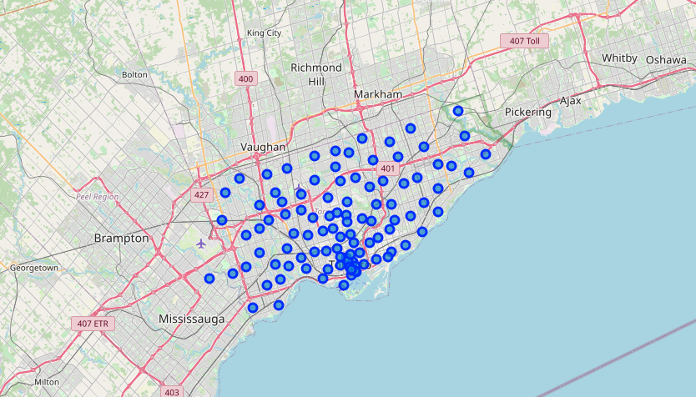

**Methodology**

After retrieving the table of neighborhoods and location details, we could implement Foursquare APIs to explore more business details in each neighborhood. By creating connection with Foursquare APIs, the analysis will continue with getting venues information. The API request is simply listed as, 'https://api.foursquare.com/v2/venues/explore?&client_id={}&client_secret={}&v={}&ll={},{}&radius={}&limit={}', while {} would be replaced by input variables.

As the lab assignment introduced, a constructor of getNearbyVenues is referenced in this part. In order of increase the scope of our searching result, the analysis will increase limit to 500. The following picture shows part of the result:

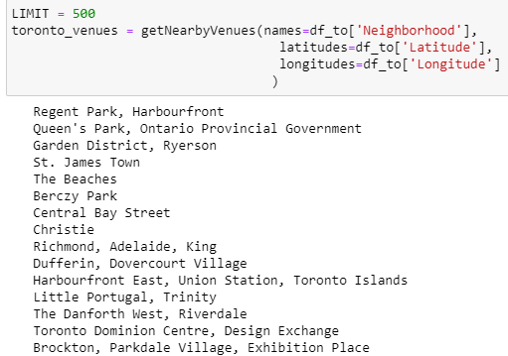

After collecting venue data, one hot encoding will be used to create dummy variables so that each neighborhood has the opportunity to probe the venue density. A part of the result is shown below:

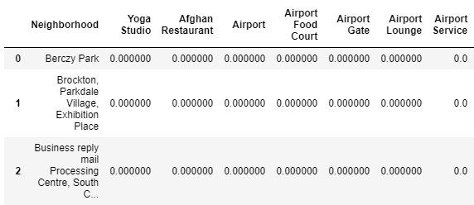

In addition, by requesting Foursqure API and loop the existing data frame, the business owner could know most popular venues in each assigned neighborhood. In this research, it will increase the result up to 10 venues to get a more specific scope. A part of result is shown below:

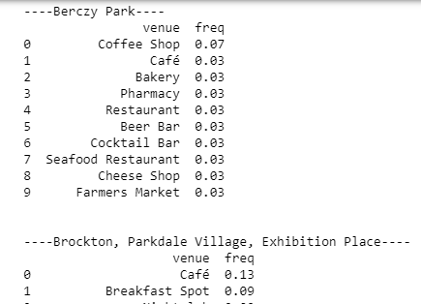

**Results**

Our business process requires that the number of video game shop is an important indicator for Gavin to choose the right location. Through our exploration, unfortuanly, due to the limitation of Foursqure’s database, there are only two neighborhoods having video game stores in record:

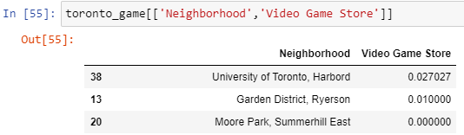

While accepting the fact that there are only two options, we could have a closer inspect into other venues details to see which option is more convenient for daily commuting:

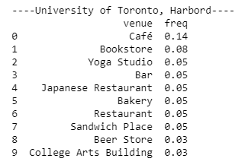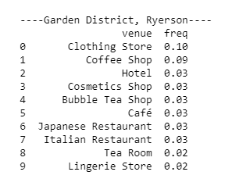

These two pictures show the density of venues in our two options and this information will help our business owner to make the final decision.

**Discussion and Recommendation**

First of all, top venues in garden district are mainly clothing stores and other shops. The high frequency of hotels and other resorting facilities indicates the area is clearly a shopping district. That is, high rental in such a CBD area should take into consideration. As for the University of Toronto, rental for nearby areas could be a concern as well but it will need further research to get more details. However, a noticeable advantage of locating university area is it’s helpful for talents recruiting. As discussed before, Gavin is setting its new game studio to a new city and employees would be hired locally. If Gavin has a long-term plan to prospect his game studio, new blood from universities is a good option for him. In addition, recreation and daily facilities are adequate enough for the studio to meet communication needs. Through the result of this analysis, I would recommend Gavin to choose the neighborhood of University of Toronto as the location for his game studio.

**Conclusion**

For a small business owner, choosing a right neighborhood to start up is vital to leverage cost in an early stage of the business. Gavin is attracted by the openness to gaming industry of Toronto city, and he intends to take the number of video game shops and the level of life convenience as two primary indicators for choosing the optimal studio location. By conducting a full analysis with Python and extracting Foursquare database, Gavin is recommended to choose University of Toronto as the best location, majorly due to the consideration of gaming atmosphere and friendly recruiting environment.